Week 05
Question 1:

Write a program that prints a simple chessboard.
Input format:
The first line contains the number of inputs T.
The lines after that contain a different values for size of the chessboard
Output format:
Print a chessboard of dimensions size * size. Print a Print W for white spaces and B for black spaces.
Input:
2
3
5
Output:
WBW
BWB
WBW
WBWBW
BWBWB
WBWBW
BWBWB
WBWBW
Program:
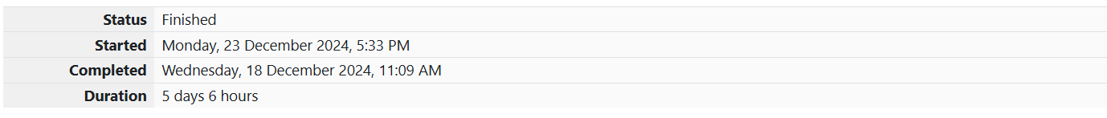
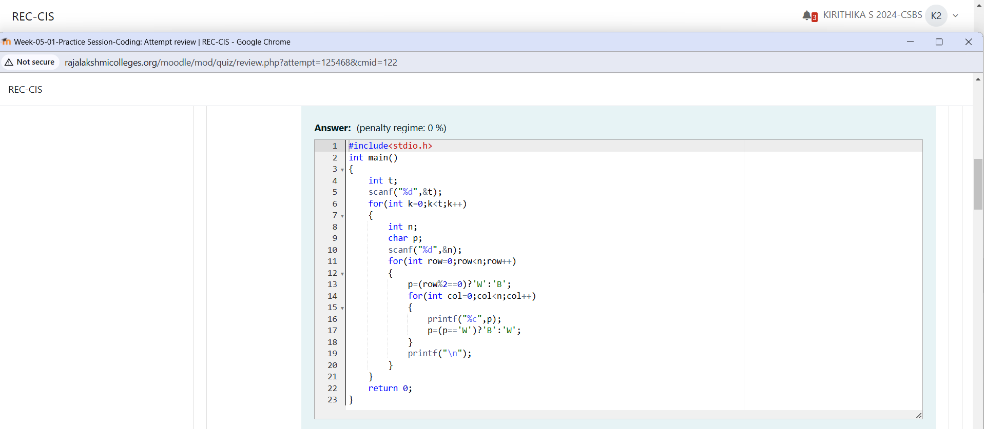
Output:
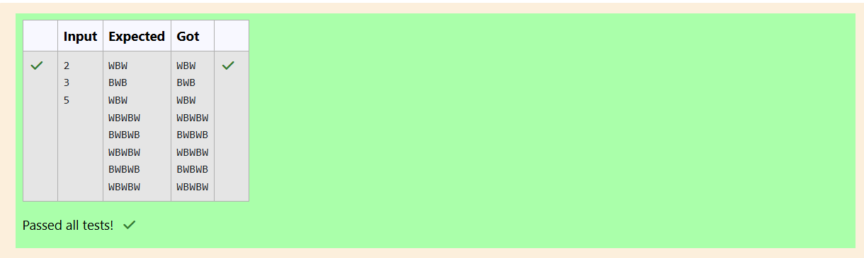

Question 2:

Let’s print a chessboard!
Write a program that takes input:
The first line contains T, the number of test cases
Each test case contains an integer N and also the starting character of the chessboard
Output Format
Print the chessboard as per the given examples
Sample Input / Output
Input:
2
2 W
3 B
Output:
WB
BW
BWB
WBW
BWB
Program:
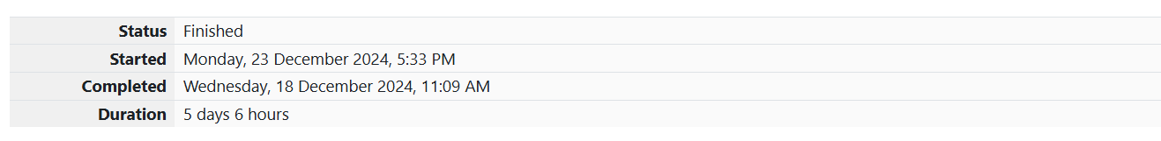
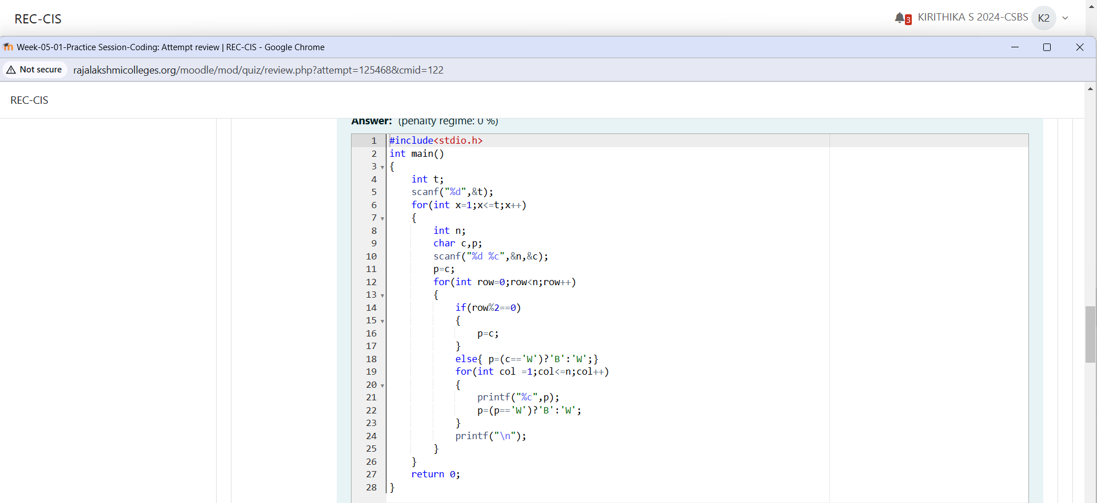

Output:
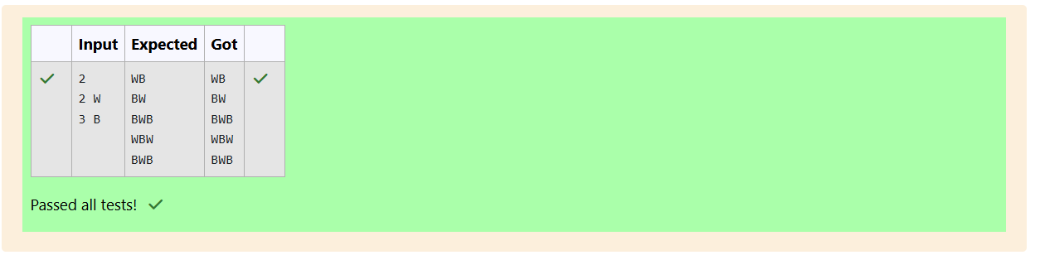

Question 3:

Decode the logic and print the Pattern that corresponds to given input.
If N= 3 then pattern will be :
10203010011012
**4050809
****607
If N= 4, then pattern will be:
1020304017018019020
**50607014015016
****809012013
******10011
Constraints
2 <= N <= 100
Input Format
First line contains T, the number of test cases
Each test case contains a single integer N
Output
First line print Case #i where i is the test case number
In the subsequent line, print the pattern
Test Case 1
3
3
4
5
Output
Case #1
10203010011012
**4050809
****607
Case #2
1020304017018019020
**50607014015016
****809012013
******10011
Case #3
102030405026027028029030
**6070809022023024025
****10011012019020021
******13014017018
********15016
Program:
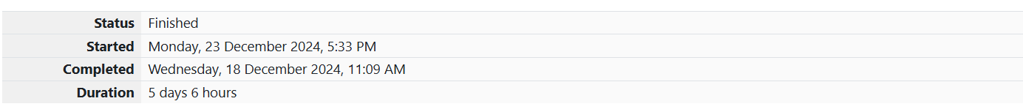
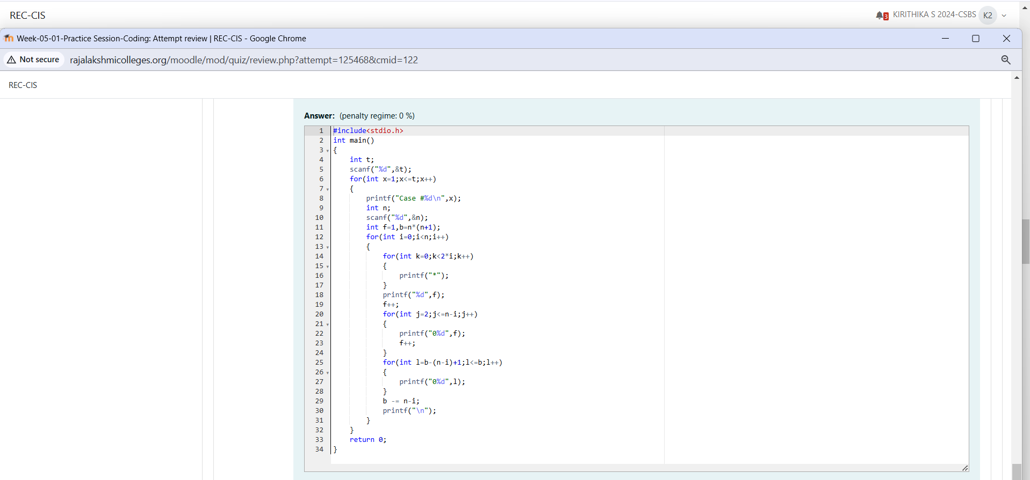

Output:
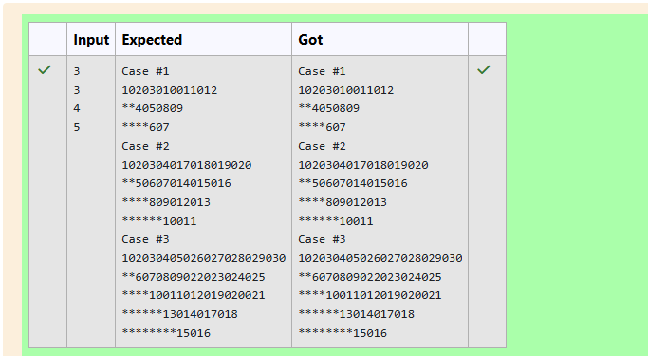

Question 4:

The k-digit number N is an Armstrong number if and only if the k-th power of each digit sums to N.
Given a positive integer N, return true if and only if it is an Armstrong number.
Example 1:
Input:
153
Output:
true
Explanation:
153 is a 3-digit number, and 153 = 1^3 + 5^3 + 3^3.
Example 2:
Input:
123
Output:
false
Explanation:
123 is a 3-digit number, and 123 != 1^3 + 2^3 + 3^3 = 36.
Example 3:
Input:
1634
Output:
true
Note:
1 <= N <= 10^8

Program:
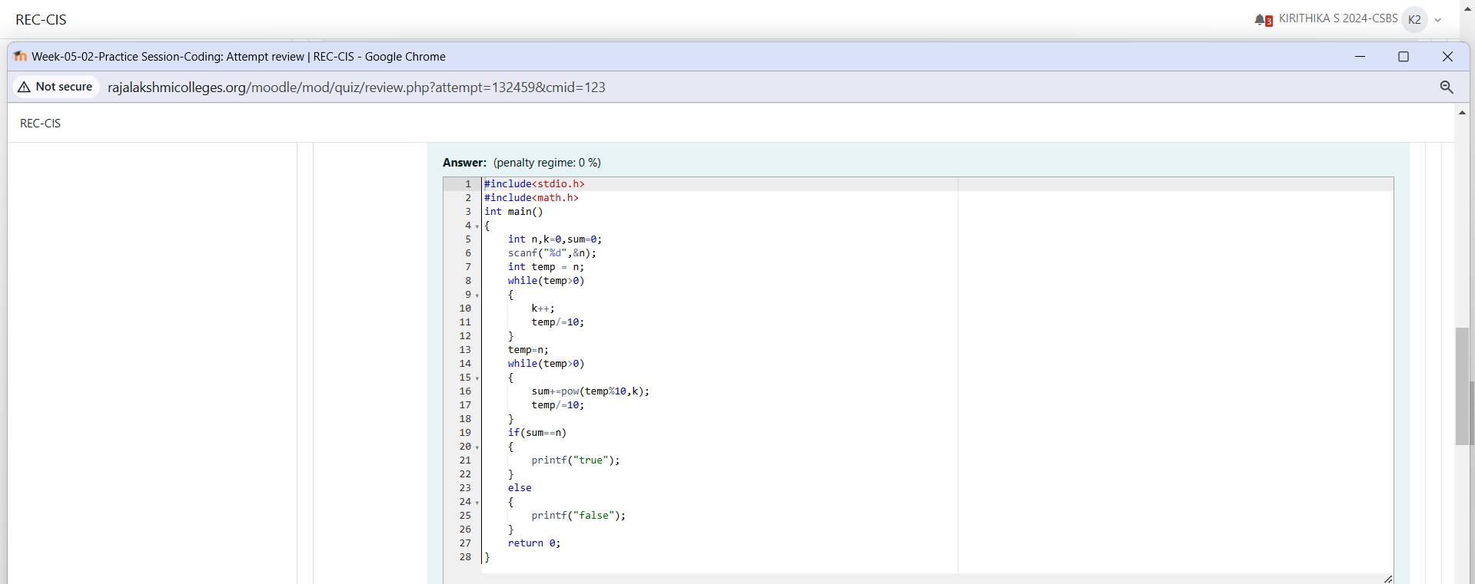

Output:
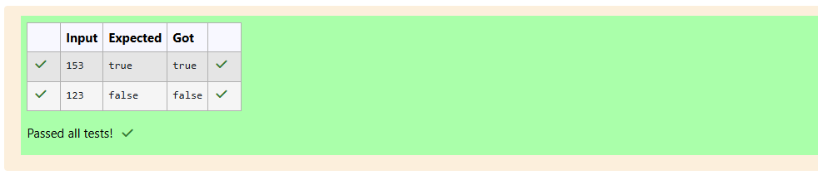

Question 5:

Take a number, reverse it and add it to the original number until the obtained number is a palindrome. Constraints
1<=num<=99999999 Sample Input 1 32 Sample Output 1 55 Sample Input 2 789 Sample Output 2 66066
Program:

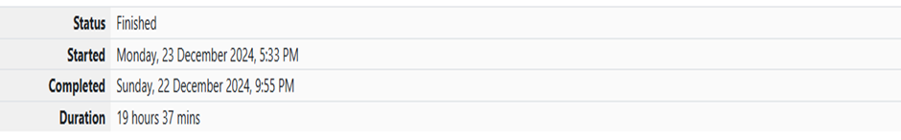
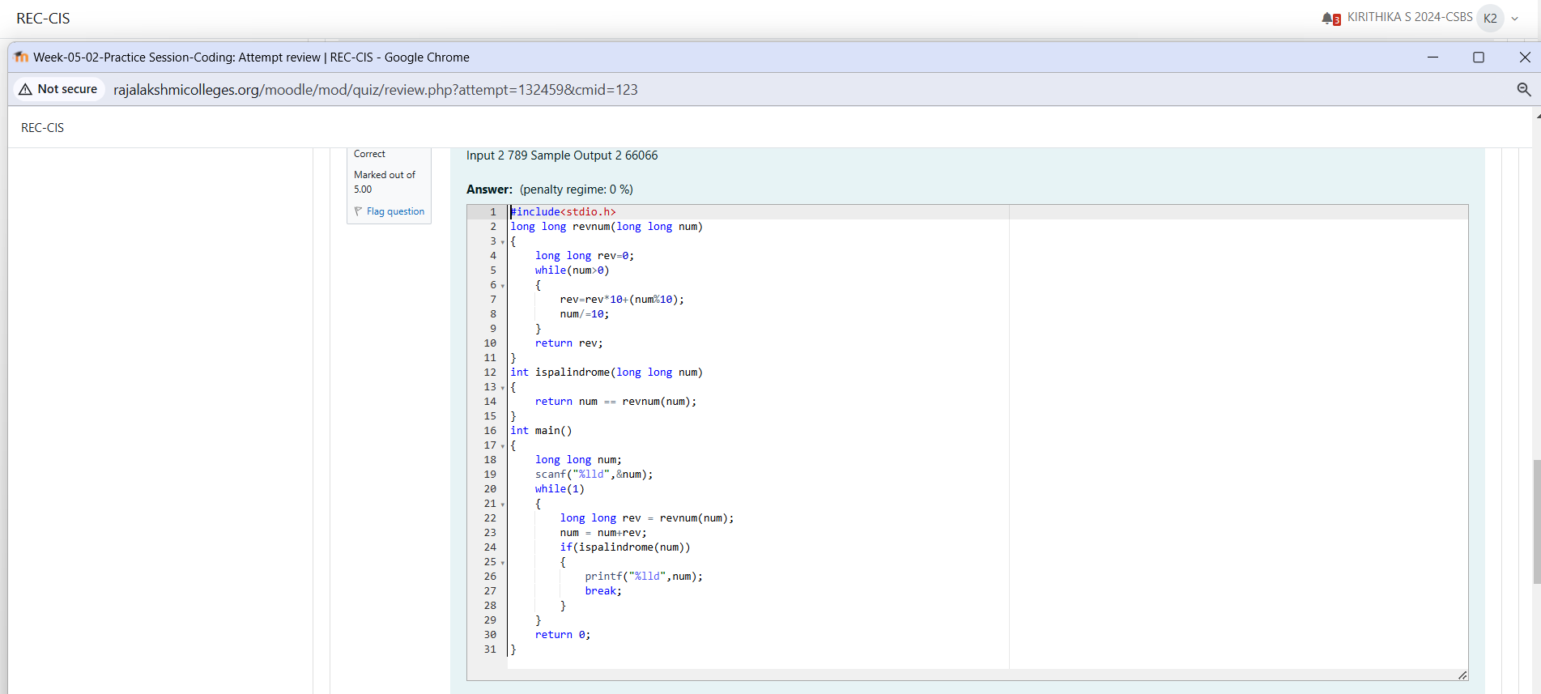

Output:
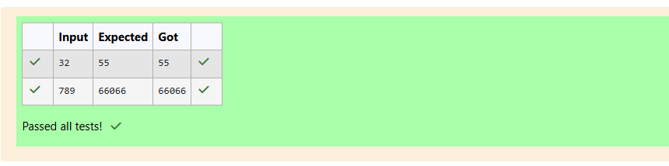

Question 6:

A number is considered lucky if it contains either 3 or 4 or 3 and 4 both in it. Write a program to print the nth lucky number. Example, 1st lucky number is 3, and 2nd lucky number is 4 and 3rd lucky number is 33 and 4th lucky number is 34 and so on. Note that 13, 40 etc., are not lucky as they have other numbers in it.
The program should accept a number 'n' as input and display the nth lucky number as output.
Sample Input 1:
3
Sample Output 1:
Explanation:
Here the lucky numbers are 3, 4, 33, 34., and the 3rd lucky number is 33.
Sample Input 2:
34
Sample Output 2:
33344
Program:

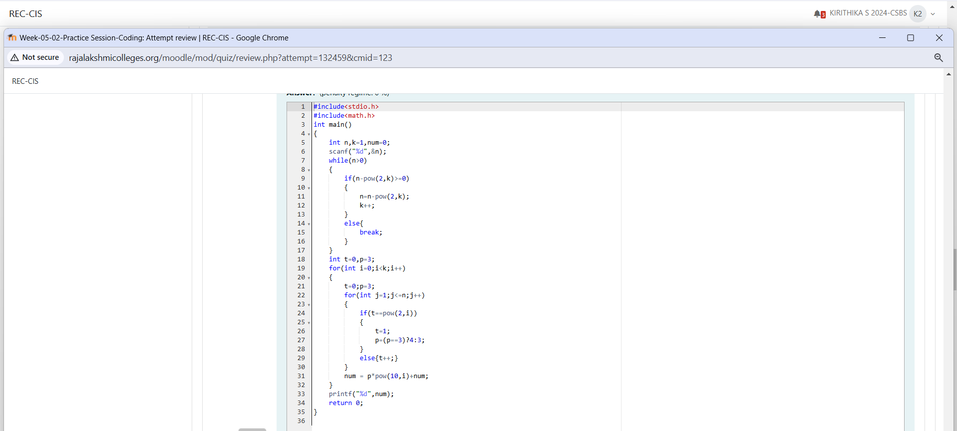

Output:
